 **GO-STANDARD NURSERY & PRI-SCHOOL**

**END OF YEAR EXAMINATION 2023**

**MIDDLE CLASS: (4 – 5 YEARS)**

**LEARNING AREA 2: LANGUAGE DEVELOPMENT I**

**My name is: ……………………………………………………………….**

**My School is: …………………………………….………………………..**

**I am in: ………………………………..…………………………….…………………..**

I. **Write letters a - n .**

a ________ _______ _______

_______ ________ _______ _______

_______ ________ _______ _______

_______ n

2. **Read and draw.**

|  |  |  |  |
| --- | --- | --- | --- |
| pot | car | girl | book |
|  |  |  |  |

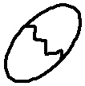3. **Complete the sentences**.

This is an___________

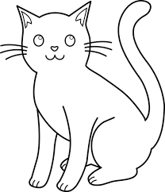

This is a____________

This is a _______________

D:\Local Disk F\New folder\KIBUUKA 2023\pictures\kibuuka pic\MAT.jpg

This is a _________________

This is a ___________________

4. **Fill in the missing letters.**

D:\Local Disk F\New folder\KIBUUKA 2023\pictures\kibuuka pic\ball.jpg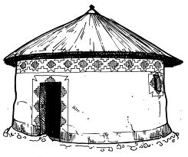

h___t ba___ ___

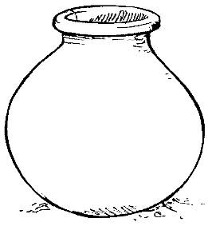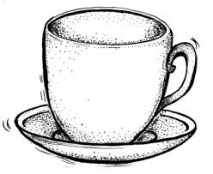

c___p po___

5. **Name the pictures.**

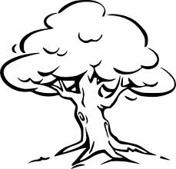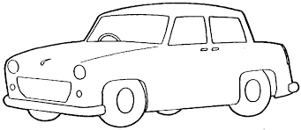

___________ ___________

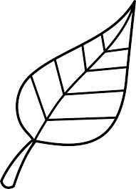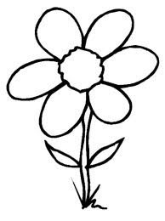

___________ ___________

6. **Find the picture number.**

2 6 egg 6 chair_____

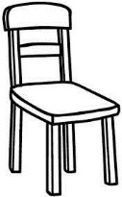pot ____ moon______

4 3

girl _____ box _______

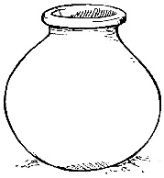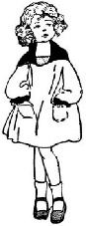

I 5

7. **Change words to small letters.**

MAT = mat

BALL = _____________

EGG = ______________

BOOK = ______________

TREE = _____________

LEG = ______________

**END**